LAB 4
DATE: 22-08-2023

WAN
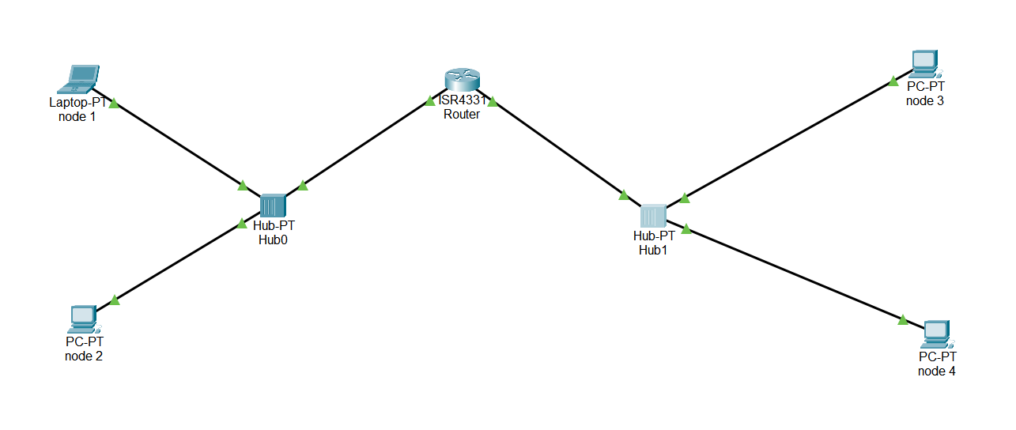
HUB TO HUB
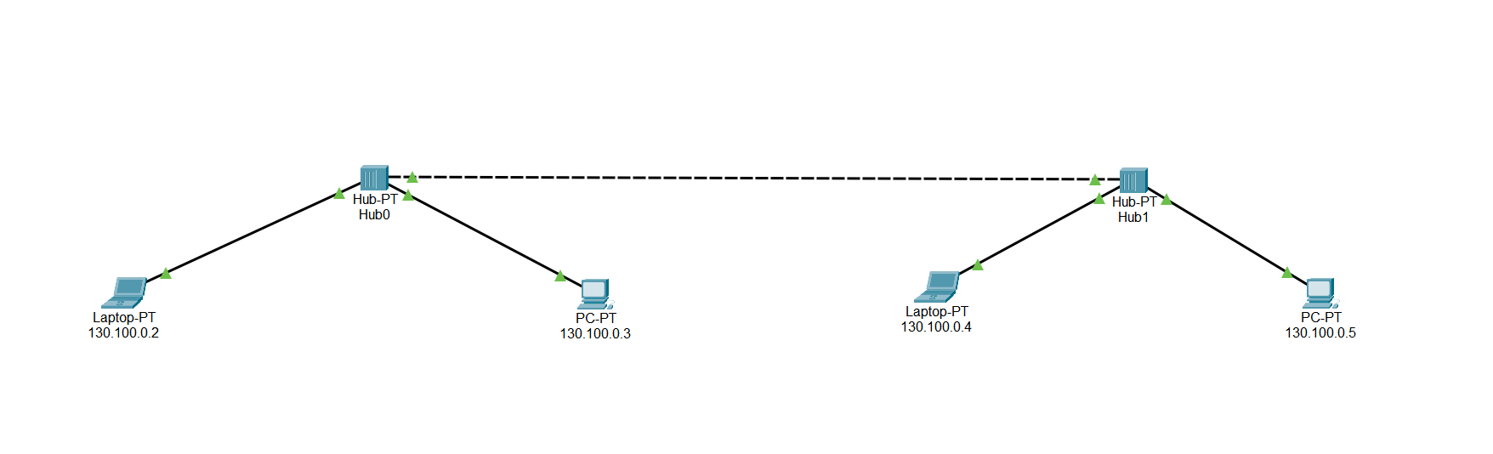
HUB TO NODE
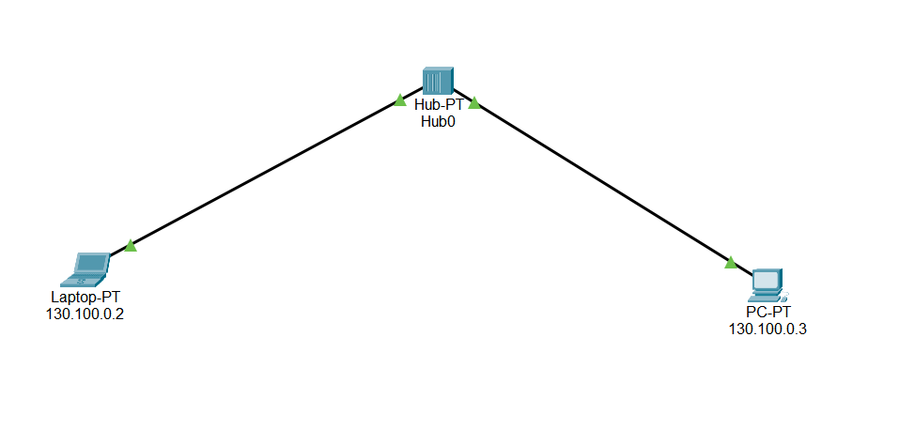
NODE TO NODE
